Intro to Unreal Engine - Part One
  - User Interface and Collisions

Overview
Unreal Engine is an immersive 3D game engine that powers some of the most popular video games in the world. While some games require teams of professionals to produce a final product, you can get started with no experience. Rather than focusing solely on basic concepts of computer programming, you’ll jump straight into designing a video game level. This series of activities is designed to guide you through the process of creating a 3D game level while highlighting the important computing and engine concepts along the way. The assets, level, and starter code for this project was provided by Epic Games, creators of Unreal Engine.

Learning Outcomes
By the end of this module, learners should be able to:
- Navigate around the Unreal Engine user interface.
- Use mouse and hotkeys to navigate within the 3D environment of the viewport.
- Place existing assets within a level.
- Add collision volumes to level assets.
- Play test their level design elements.

Getting Started – Installing Unreal Engine
If you are working on a lab PC then Unreal Engine will already be installed.
Ensure that you are working with Unreal Engine 5.5.1. If version 5.5.1 isn’t installed, then please install it before continuing.
If you wish to work on this project at home, follow these steps:
- To download Unreal Engine, you will need to create an Epic Games account on epicgames.com. Visit the site and create your account now.
- Download and install the Epic Launcher from the Epic Games Store Website. Navigate to the site and in the upper right corner, you will see the ‘Get Epic Games” link. Once downloaded you can open the file to run the installer.
- Select “Unreal Engine” from the left-hand side menu.
- Click the “Install Engine” button. Note that the engine is over 36 gigs in size, so you want to install it to a hard-drive with a lot of free space.

Starter Files – Downloading and Installing the Starter Project
The starter files can be downloaded from the “Project #1 – Intro to Unreal Engine” content section on Learn, or by following this link.

Your Developers Journal
While working through the five modules of this assignment you are expected to keep a journal documenting:
- The things you learned in each module.
- The places you got stuck and how this was resolved.
- The external resources you found helpful.
- The mistakes you made and their subsequent fixes.
Your journal entries should be organized by date and must include screenshots where appropriate. (The ⊞ Win+⇧ Shift+S hotkey is your friend!) Animated gifs or short videos would work as well instead of, or along with, the screenshots.
You must write a minimum of one entry per module, but more than that is fine.
At first keeping a journal may feel like a pain, but over time I hope that you will come to appreciate the journal as a record of your learning journey and a valuable source of reference materials. Your developer journal can be written in Word or using an online tool like Notion.so (or Microsoft Loop. Other tools are possible, but please clear them with your instructor first.)
An example of a developer journal kept by your instructor Kyle Geske while he learned the basics of Android mobile programming can be seen here.

Rubric
Before continuing, please take a moment to review how you will be marked on this project.

Parkour
In this activity, you will learn how to build a parkour course to get the player through a simple hallway, and across a treacherous void. For our purposes, parkour refers to the player running and navigating jumps of varying difficulty over a deadly void. Be mindful that difficulty does not always equal fun. You may think your level is too easy to complete, but this may be because you are the designer and have played through your level many times.

Collision Detection
In the real world, it’s easy to understand how you can sit in a chair, stand on the floor, or hit a ball because they are all physical objects. In a virtual 3D world, the concept of physical objects needs to be defined in code. The moment when two objects collide or overlap is called a collision. When objects collide, Unreal Engine can identify which objects collide and how each object should react. You will learn the critical importance of collision detection in this activity.

Unzipping the Project and Reviewing the UE Interface
This activity will give you a chance to get familiar with navigating Unreal Engine user interface in the Viewport. To begin, unzip the starter project you downloaded to a known location on your hard drive. You can do this by right-clicking the zip file, selecting “Extract All”, and then clicking “Browse...” to pick the destination folder for the project.
Next, open the project by double clicking the IntroToUnrealEngine.uproject file. Unreal will likely ask you to confirm your version of Unreal. If Windows says it doesn't know how to open the file, following this YouTube tutorial.
Let’s start by taking a look at the Unreal User Interface (UI). Start by locating the Content Browser (Figure 001). This browser can be opened by clicking the button in the bottom left corner of the screen or by using the CTRL-Space hotkey. It will auto-hide when you click elsewhere in the engine.
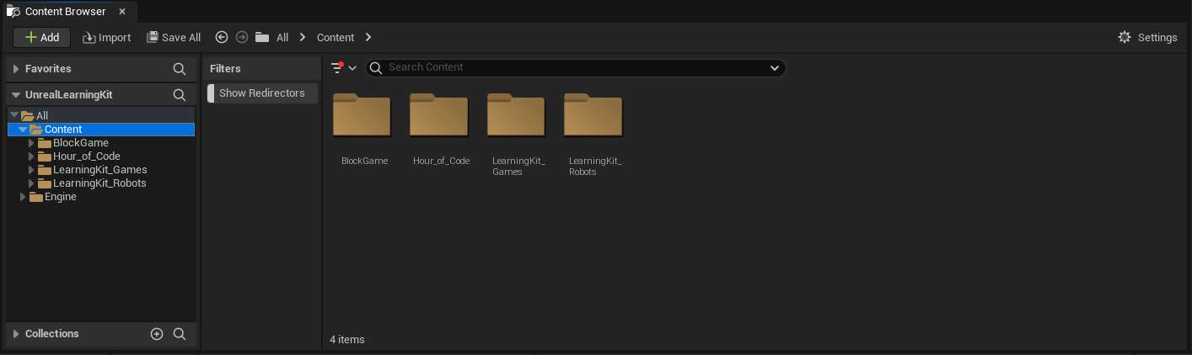
Figure 001 – The Content Browser Panel
You can change the color of the folders to make it easier to find them. The folder we’ll be working with the most is “Hour_of_Code”. Let’s change its color to make them stand out. Right-click each folder and choose Set Color. Then choose a color.
The Place Actors panel (Figure 002) contains assets like Lights and Trigger Volumes. If you ever close this panel, it can be reactivated by navigating to Windows > Place Actors. These assets will be available in every project you create. This is different than the Content Browser because the Content Browser will also contain assets that you can import from 3D design programs like Autodesk’s Maya, 3D Studio Max, and Blender.
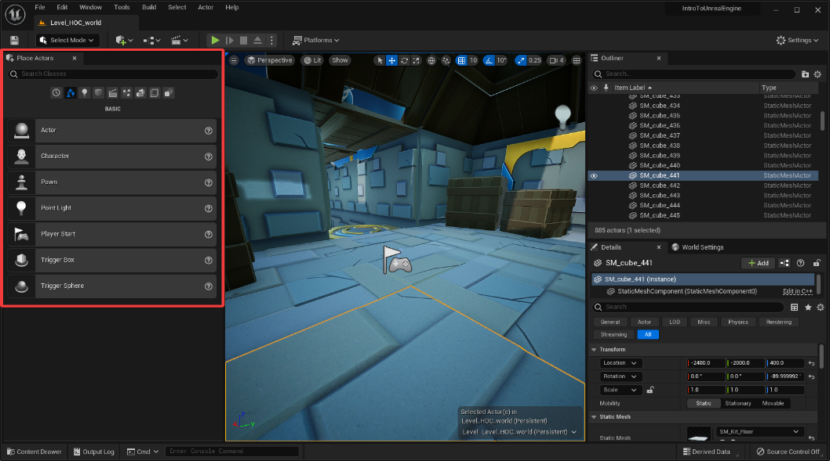
Figure 002 – The Place Actor Panel
🤖 TECHNICAL JARGON DEFINED
Actors – The term “Actors” is used to identify the various objects or elements that are in a Level. While the phrase is commonly used to identify people in film and TV, it is a more general term when used in the context of your Unreal Engine projects. Scene props, the various parts of the environment, NPCs, and your player character are all types of Actors in Unreal Engine.
We will be doing most of our work in the Viewport (Figure 003). This is the large area in the middle of the screen where you will place assets from the Content Browser.
When navigating in the Viewport there are a few different ways to control the camera. First, these controls work with no other keys or buttons pressed.
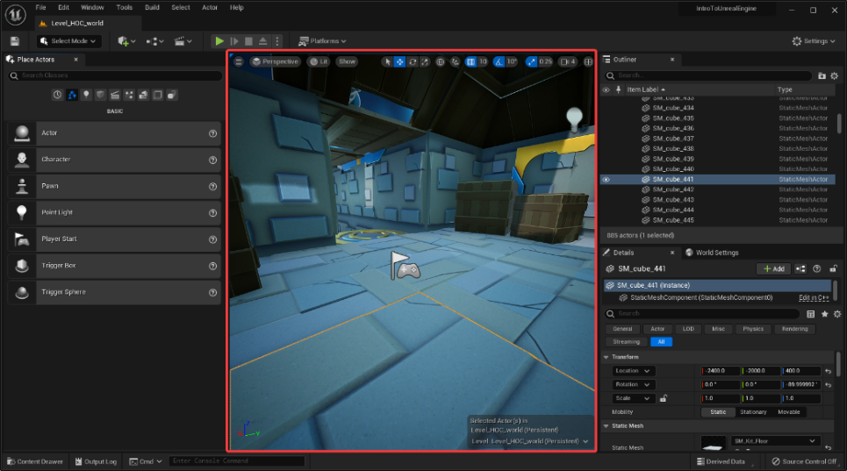
Figure 003 – The Viewport
Try this:
- Hold LMB (left mouse button) and drag the mouse to move the camera forward and backward or rotate it right and left.
- Hold RMB (right mouse button) and drag the mouse to rotate the camera up, down, left, or right.
- Hold MMB (middle mouse button) and drag the mouse to move the camera up, down, left, or right.
- The speed of your camera can be controlled by using the camera icon in the top right corner of the Viewport. (Figure 004)
- If your mouse has a scroll wheel, you can use that to zoom in and out.
- Next hit the number ‘1’ on the keyboard. This will ensure that you are in the correct position within the world for this tutorial.
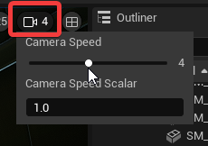
Figure 004 – The Camera Speed
The WASD keys can also be used whenever you hold down the RMB:
- W – Forward
- S – Backward
- A – Left
- D – Right
- E – Up
- Q – Down
- C – Zoom in (Without Changing Position)
- Z – Zoom out (Without Changing Position)
You can also frame any selected asset or actor. Select an asset in the viewport, then press the F key and see what happens. Select another asset and press the F key again.
With an asset or actor framed you can tumble around the object or dolly in / out:
- ALT + LMB = Tumble Around Framed Object
- ALT + RMB = Dolly In / Out
If you need to deselect an Actor, hold Ctrl and click the Actor.
🤝 PRO TIP FOR THE WIN
Hotkeys Save Time – We’ve just scratched the surface in terms of the hotkeys available in Unreal Engine. Check out these resources. You may wish to print these out or use them as your desktop background.
See the further reading section at the end of the document for some hotkey cheat sheets!
Next, open the Levels panel. This can be displayed by navigating to Windows > Levels. Click and drag the window by the tab to dock it next to the World Outliner (Figure 005).
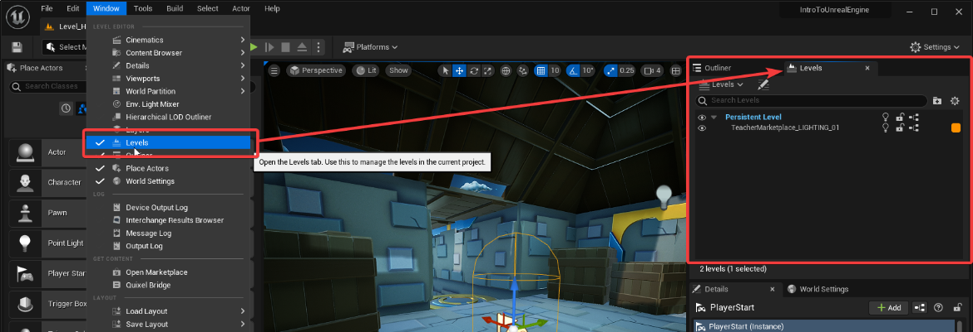
Figure 005 – Docking the Levels Panel
The Details window, also referred to as the Details Panel, will show editable attributes of any Actor that is selected in the Viewport. Any asset placed into the Viewport is referred to as an Actor. You can think of them as similar to actors on a stage, but they are Actors in your game. Select the PlayerStart Actor and you will see the Details Panel update (Figure 006).
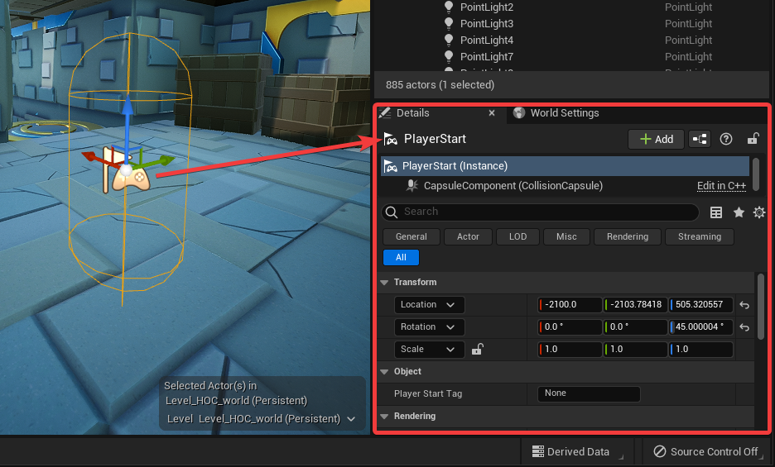
Figure 006 – Player Start Details in the Details Panel
We will also be using the World Settings. If not available as a tab beside the Details tab, go to the Window menu and select World Settings (Figure 007). This panel contains information about the game’s 3D world. For these activities, we will be working within the Persistent Level, and we will only be editing the world settings for the Persistent Level.
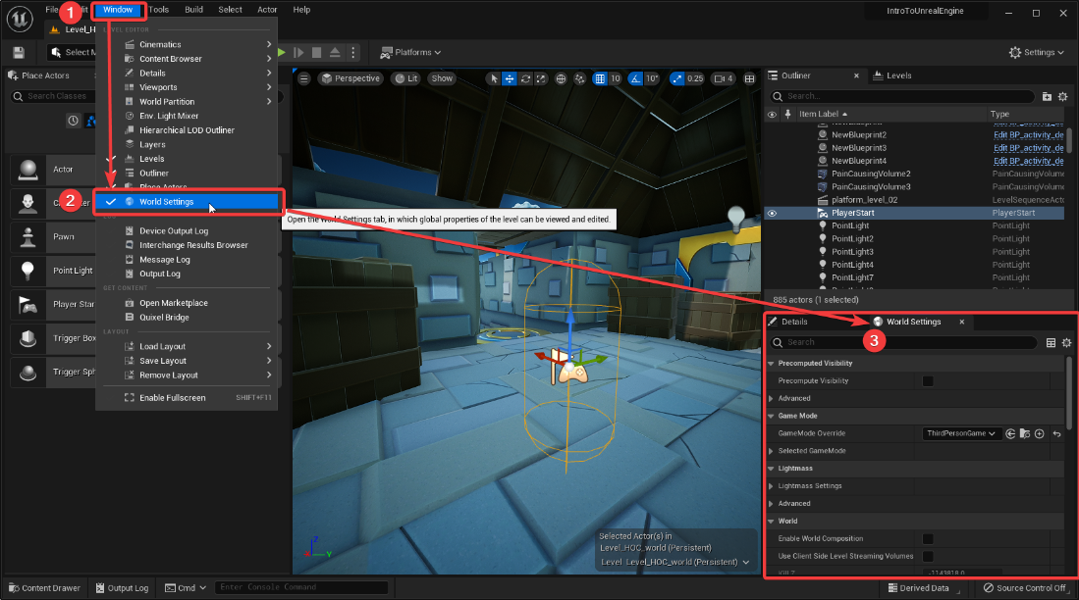
Figure 007 – World Settings

Let’s Play!
Let’s jump right in! Click the Play button at the top of the screen, or press Alt + P.
Move your mouse over the Viewport and click the left mouse button. This will give you control of the player. You can use the mouse to look around, and the following keys to move:
- W = move forward
- A = move left
- D= move right
- S = move backward
- Space = jump
- Hold Shift while moving = sprint
These controls are specific to this game.
Try to get to the end of the tunnel (Figure 008) to the outside. What happened?
Press the Esc key on the keyboard to leave the game and return to edit mode.
You’ll notice that your character falls through the platform in the tunnel (Figure 008), and lands at the bottom of the pit. This is because the platform has no collision associated with it, it is only being drawn visibly in the world. The game doesn’t yet know that the player should be able to stand on this platform. Let’s create a Collision Volume for this asset.
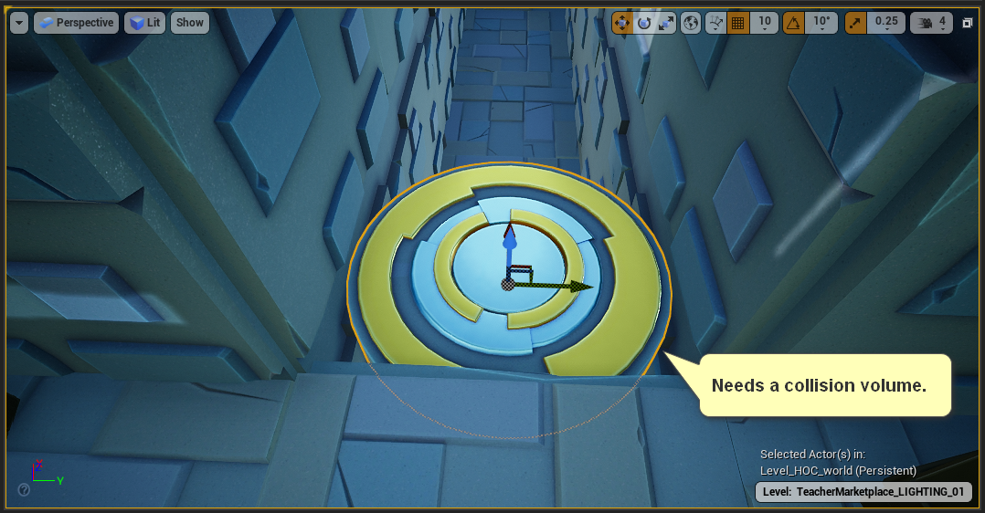
Figure 008 – This Platform Needs a Collision Volume

Fixing the First Platform
To fix our problem with the platform, we will need to establish a collision area for that object. The object has a shape and texture that allow it to be visualized in the game, but this is separate from its collision properties. We need to add a collision volume as an invisible shape that is attached to the object. We can make the collision match the shape of the object or customize the shape to fit the needs of our game.
Select the platform Actor in the Viewport and press Ctrl + E, this will open the Static Mesh Editor for this asset.
🖖 LENDING A HELPFUL HAND
Lost? Did you navigate the camera away from the start of the level? If you are having trouble navigating back to the first platform, press the number 1 on your keyboard. This is a camera bookmark that will take you to the correct location. We’ll look more into camera bookmarks in the next module.
NOTE: You can also open the Static Mesh Editor by navigating through the Content Browser: Content > Hour_of_Code > Static_Meshes and double-click on the SM_Platform_M asset.
With the Static Mesh Editor open, click on the Collision button at the top of the interface and select Add 10DOP-Z Simplified Collision (Figure 009).
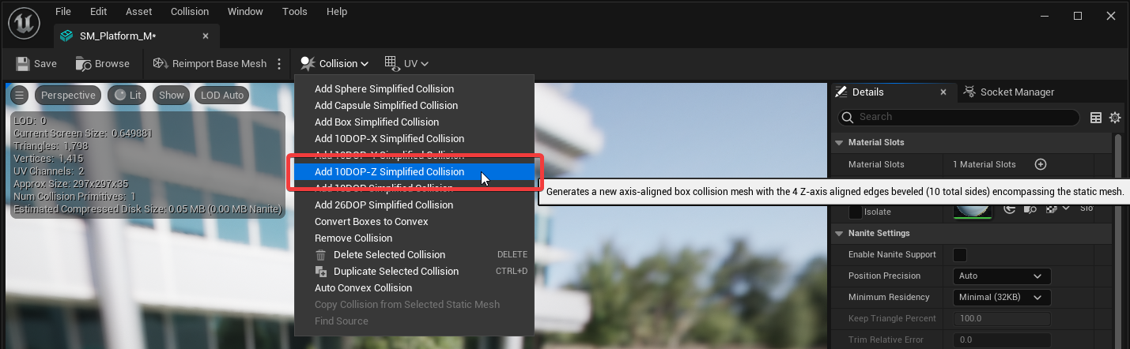
Figure 009 – Adding a Simple Collision
This will create a simple collision volume that fits around the platform. You will see a green shape appear around the platform (Figure 010). It will not fit exactly to the platform, and it does not need to, it just needs to be close enough to work for our gameplay purposes.
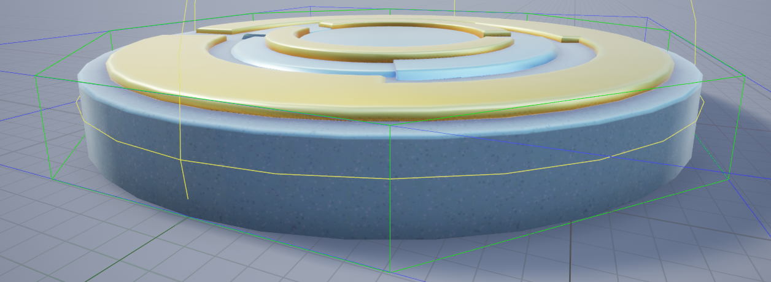
Figure 010 – Green Collision Volume Outlines
Click the Save button in the top left to apply the changes, and then close the Static Mesh Editor by clicking the X button in the top right of the window.

Review the Player Collision Definition
Let’s take a moment to look at the collision on the player character. This will be important for understanding how the player’s collision volumes interact with the collision volumes of objects in your level.
To get a copy of the character, navigate through the Content Browser: Content > Hour_of_Code > Blueprints > Game and then click and drag the BP_HourOfCode_Character into an open space in the level. Then press Alt + C, to show the collision on all objects in the world (Figure 010).
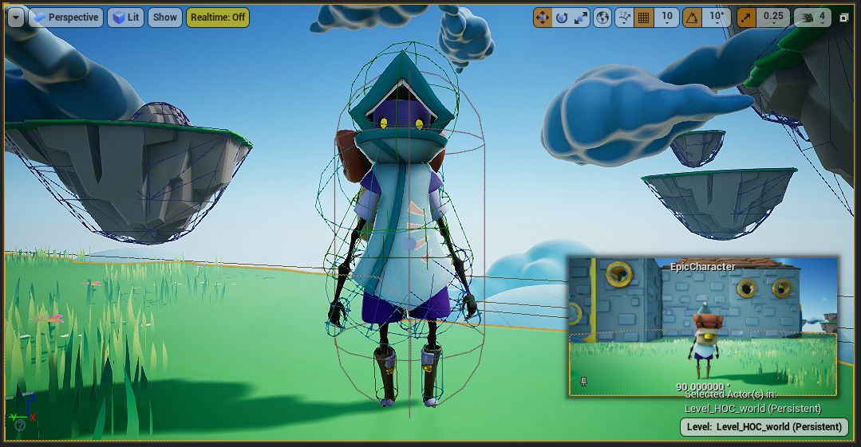
Figure 010 – Character and World with Collision Volumes Showing
You will see the various collision volumes that make up the character’s body sections. These collision volumes are used to determine if the character can walk on other collision volumes, and in the case of taking damage, where the character should be affected.
If you look at the platform you will also see the collision you have created. Can you spot the other collision volumes for all the other Actors within the level? Press Alt + C to toggle OFF the collision preview in the viewport, then select the character we just added and press Delete on the keyboard to delete it from the level. (Don’t worry, the character will still get spawned into the level when you press play.)
Now that we have created Collision on the platform, and we have a better idea of what collision does for our player, we should playtest our platform to make sure it works. Play your level again and double-check that everything is working correctly. Does the player fall through the platform? Go back and double-check your work.

Adding More Platforms with Duplicate
Great! You should have the player walking on the first platform. Now we need to complete this hallway so the player can safely reach the other side. We are going to use a shortcut that quickly copies our platform so we can place the platforms needed to get across the hallway.
First, select the platform. Hold the Alt key, then click and drag on the red arrow of the move gizmo (Figure 011) to duplicate the platform down the hallway. You will need to let go of the Alt once you have created the duplicate, then hold it again to create a new duplicate. Try holding Shift and Alt when duplicating/moving a platform to have the camera follow your movement. Once you have a few platforms in place, test your level to see if you can get across.
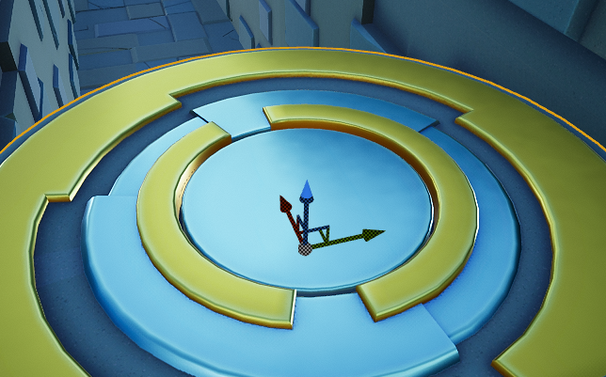
Figure 011 – Platform with the three color “move gizmo” in the centre.

Handling Failed Attempts
If you fell in the pit, you probably noticed that your character is unable to make it out. This is referred to as a “showstopper” or “soft lock”. The game hasn’t ended and there’s no way for it to progress. Since the game engine doesn’t know the goal of your game, it is only doing what you tell it to. If you want the player to “die” or “restart” you must add that manually.
We can address this bug by placing a Pain Causing Volume in the pit that will reset the player and send them back to the Player Start.
Try this:
- Reset the camera position to start – press the alpha numeric number 1.
- In the World Outliner, search for the existing SM_Platform_M element and make it invisible by clicking the eye icon.
- In the Place Actors tab, type “pain” into the search bar (Figure 012).
- Drag and drop a Pain Causing Volume from the Place Actors Panel into the Viewport.
- With the Pain Causing Volume selected you can use the W and R keys to switch between the Move Gizmo and the Scale Gizmo.
- Move and scale the Pain Causing Volume such that the player will collide with it when they fall anywhere into the pit.
- You may find it helpful to select the Pain Causing Volume, hit f to frame it, and then tumble to a top view using ALT-LMB.
- Hide any geometry that gets in your way by clicking on it and hitting h.
- Unhide all hidden geometry using CTRL-h.
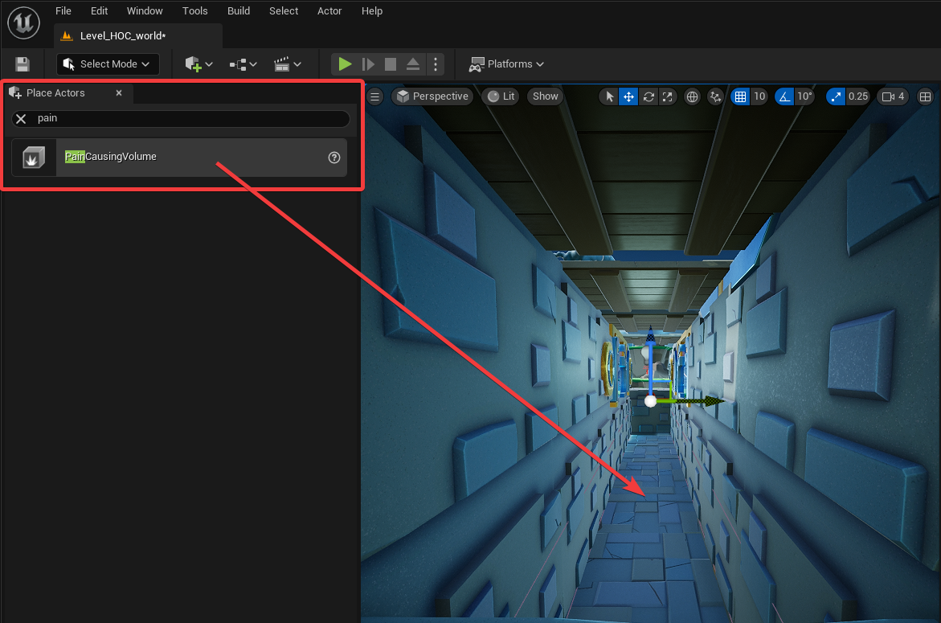
Figure 012 – Placing The Pain Causing Volume Into The Level
When placing the volume, you might also want to check the orthographic views of the scene. To do this click the maximize/restore viewport icon in the top corner of the Viewport (Figure 013).
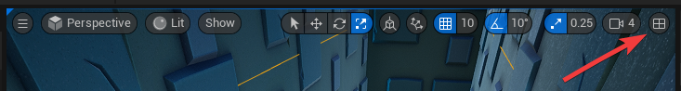
Figure 013 – The Maximize / Resort Viewport Button
To navigate an orthographic view right-click and drag to move and use the mouse wheel to zoom. You can maximum any of the orthographic views using their viewport icon (Figure 014). Due to the complexity of the geometry in the level, the orthographic views will be very dense with lines.
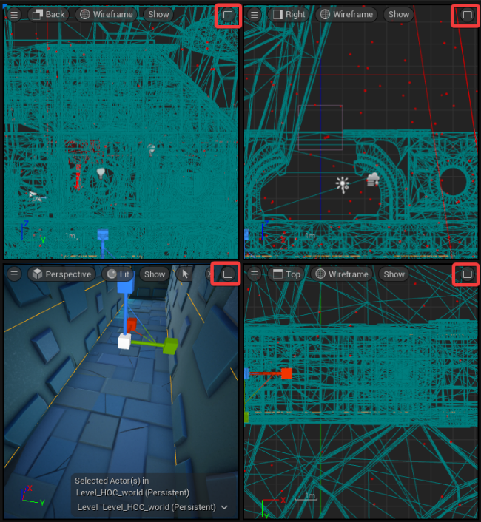
Figure 014 – Maximize any of the view using their viewport icon.
With the Pain Causing Volume in place, play the game again and check that your character resets when they jump into the pit. You might need to move the Pain Causing Volume around a little bit to get it to work the way you want.

Detect Falling Into The Void
Now that you can jump through to the end of the hallway, try jumping off the large island at the end of the level. Yeah, that seems unsafe, but is it? Go ahead, give it a try. What happens?
Press Esc to stop the game and press the number 1 to reset your view to Level 1.
It looks like we are missing yet another collision. In this case, the player just keeps falling. This is because the game doesn’t know that you want to restart after falling a specified distance. We will address this issue by enabling the Kill Z Bounds, a plane that will reset the character when it touches it.
In the World Settings panel, search for the word “world”, toggle Enable World Bounds Checks on, and set the Kill Z to a value of –4000. (Figure 015)
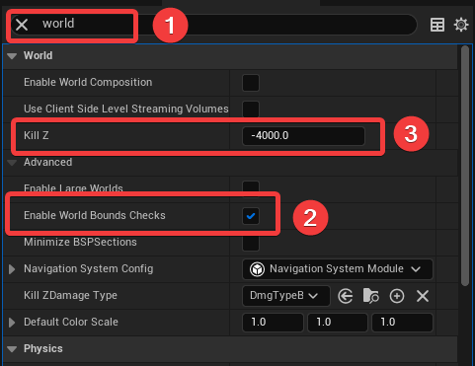
Figure 015 – Setting the Kill Z Value for the World.

Build a Parkour Course to the Next Level
Now it’s time for you to get creative! Once the player has made it through the hallway jumps, they see exciting new destinations that are floating in the sky. The only way to get to the next destination is a path of floating islands. This is where you come in. In this exercise, we will show you how to place a floating island in the world. Then, it will be up to you to use your level design skills to create a path to the next destination.
Let’s start by adding a small floating island to the scene. It can be found in the Content Browser under Content > Hour_of_Code > Static_Meshes folder. Click and drag one of the SM_FloatingIsland_S assets into your scene (Figure 016).
Use the arrows on the Move gizmo to move this first floating platform into your desired location. If you do not see the Move gizmo, select your floating island, and press the W key. Remember to use the icon in the top-right of the viewport to toggle the view.
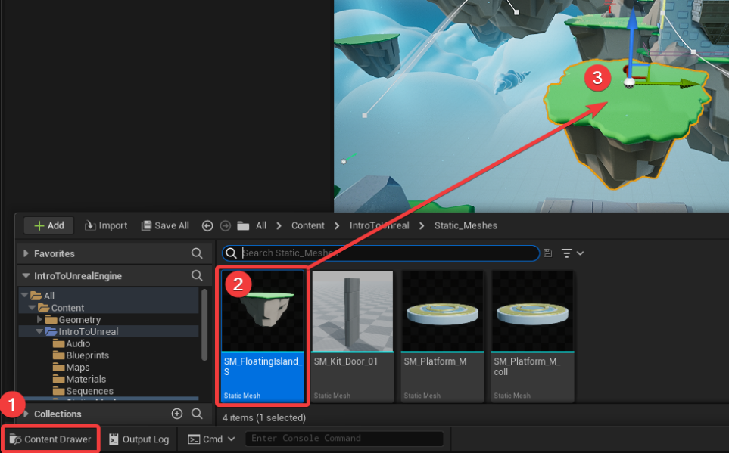
Figure 016 – Adding a floating island to your level.
With one floating island in the scene, you can duplicate it just like you did with the platforms. Hold Alt + click and drag one of the arrows of the move gizmo to create another floating island. Add, move, and scale these islands to create a path that will reach the far platform. Press the 2 key to quickly move to the location of the final destination of your parkour route.
🤝 PRO TIP FOR THE WIN
Accelerate your play testing. Want to quickly test your jumps in the game? Click the three dots to the right of the Play button. Change the ‘Spawn Player at’ option to Current Camera Location (Figure 017), then click the Play button to start your player at the current camera position. Don’t forget to change it back to Default Player Start later!
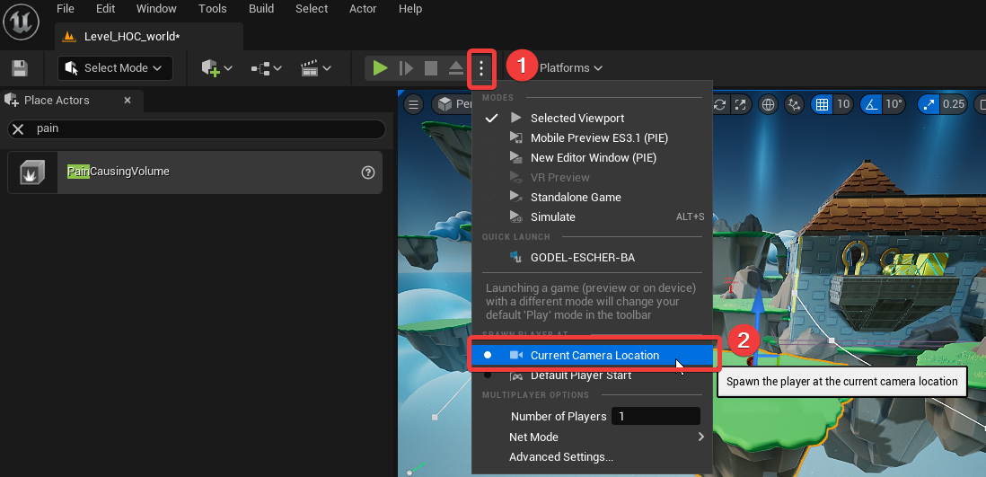
Figure 016 – Spawn at Current Camera Location
Again, we want to play-test this, so try and jump from one platform to the next to see if you can create a path your players will enjoy traveling through. Can you build a set of platforms that gives the player a few different choices to get to the next section? Players enjoy having choices, it creates a more non-linear experience.
Be sure to Save your work by navigating to File > Save All, or by pressing Ctrl + Shift + S on the keyboard.

Play Testing
Now that your parkour route is complete you should play test your level by getting two other people to attempt your route. Watch your play testers play the level, but don’t tell them where to go. Observe where they get frustrated or where they get lost. Use these observations to improve your route to make it more intuitive and more fun.

Part One Completed!
Congrats! You now know the basics of interacting with the Unreal Engine user interface. You can place, move, scale and duplicate actors in a scene. With these skills you can craft levels with jump-based game mechanics.

What’s Next?
You have now completed the first of the five Intro to Unreal Engine modules. In the next module we’ll add some checkpoints and some moving platforms. We’ll also take a look at Unreal’s visual scripting language Blueprint.
🚀 YOUR PROGRESS
    

Further Reading
- Unreal Engine 5 Keyboard Shortcuts
- UECasts’ Editor Cheatsheets:
  - Darkmode Cheatsheet
  - Lightmode Cheatsheet
- Official Guide to the Details Panel with the Level Editor
- Official Guide to Unreal World Settings
- UE4 Hotkeys, which should still be relevant to UE5:
  - Jeff Hatton’s UE4 Hotkey Cheatsheet
  - Designer’s Guide to UE4 Hotkeys (Includes animated gifs showing helpful techniques.)

